

|  |  |
| --- | --- |
| **Date** | **21th April 2023** |
| **Team ID** | **NM2023TMID33382** |
| **Project Name** | **Retail Management Application Using Salesforce** |
| **Team Leader** | **ARPUTHA .K** |
| **Team Member** | **ABINAYA .A** |
| **ABIRAMI .M** |
| **ABITHA .S** |

**1 INTRODUCTION**

* 1. **Overview**

Retailing encompasses the business activities involved in selling goods and services to consumers for their personal, family, or household etc. A CRM product owner has requested to create two applications, one is a sales app for sales reps to use this application and store customers data, and the second application is a service app for service reps/agents to provide support to customers in dealing cases. To generate business on top of the customers.

**1.2 Purpose**

Retail management saves time and ensures the customers easily locate their desired merchandise and return home satisfied.

# 2 PROBLEM DEFINITION & DESING THINKING

* 1. **Empathy Map**

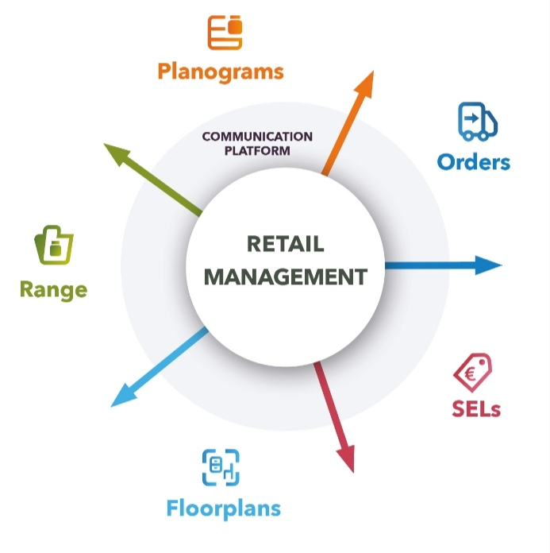

* 1. **Ideation & Brainstorming Map**

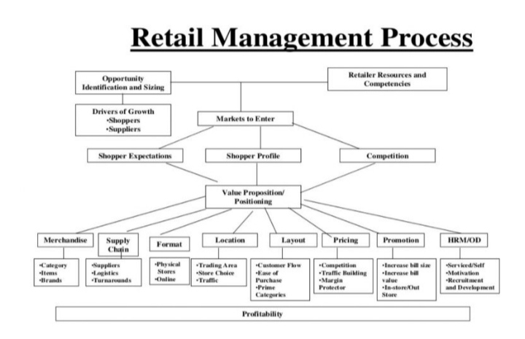

# 3 RESULT

* 1. **Data Model**

|  |  |  |
| --- | --- | --- |
| Object Name | Fields in the Object | |
| Field Label | Date Type |
| Job Posting Site | Dispatch/tracking | Checkbox |
| Dispatched | Checkbox |
| Tracking ID | Checkbox |
| Sales order | Master-Detail |
| Display/tracking | Checkbox |
| Review | - | - |

* 1. **Activity & Screenshot Milestone 1:**

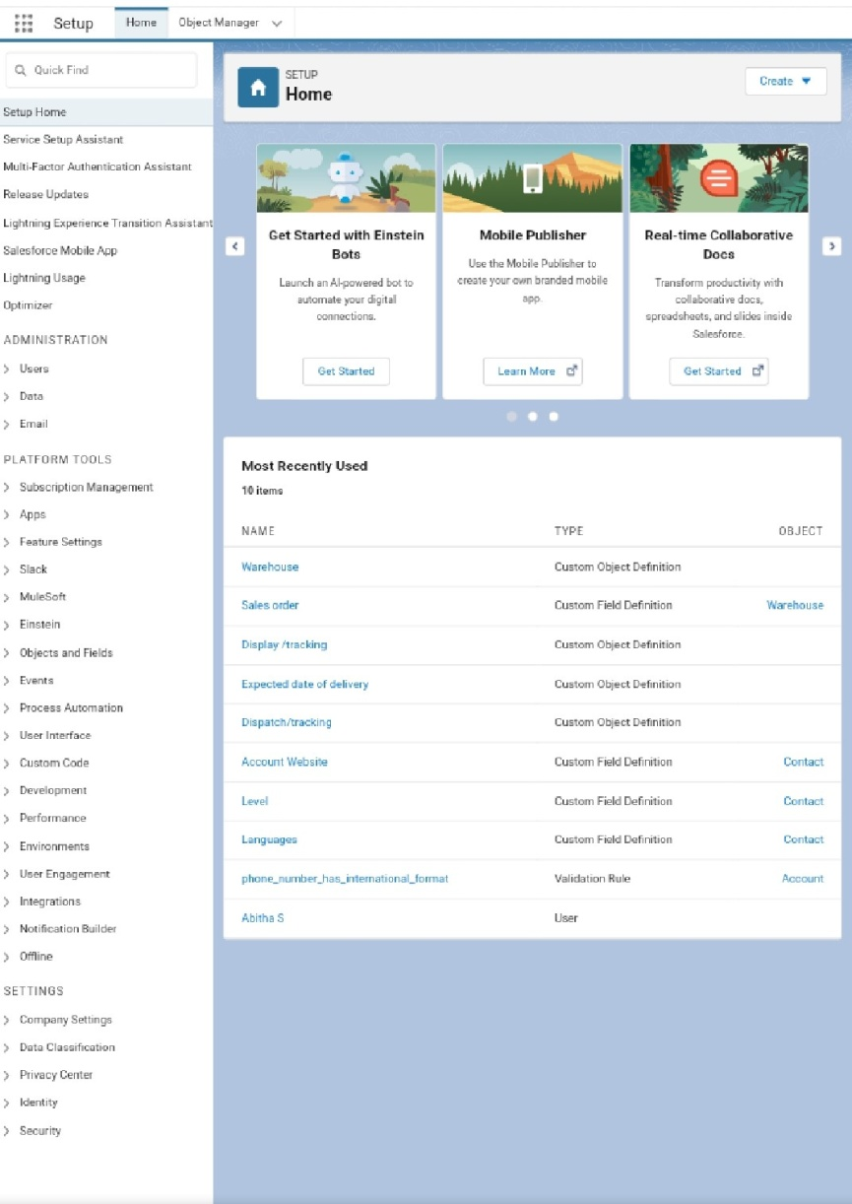

**Creation of Salesforce Account.**

Milestone 2:

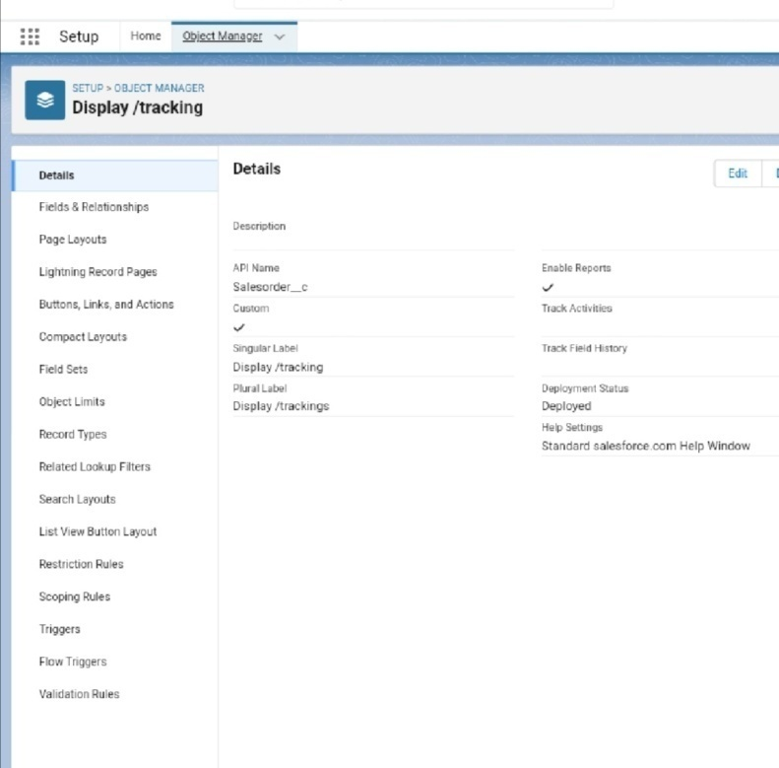

Package Installation for Recruting App

Milestone 3:

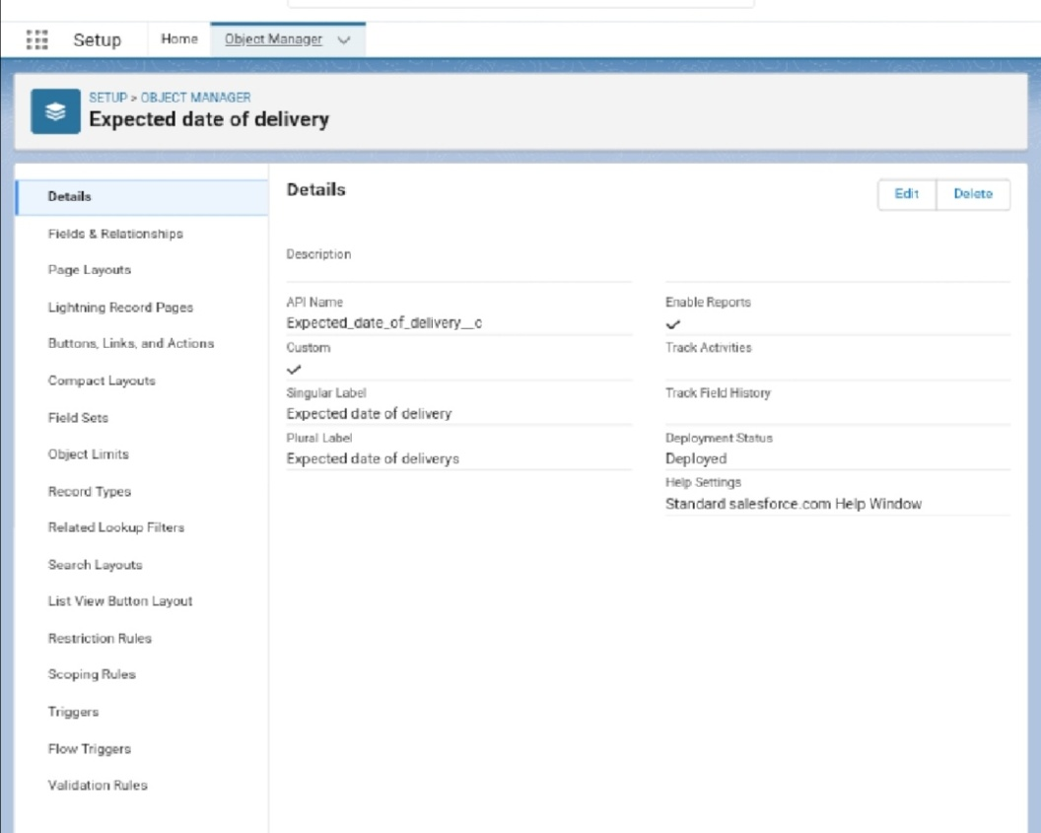

Creation of Objects ( Expected date of delivery , Dispached , Display/tracking , Sales order , Tracking Id , Dispatch/tracking & Review)

Milestone 4 :

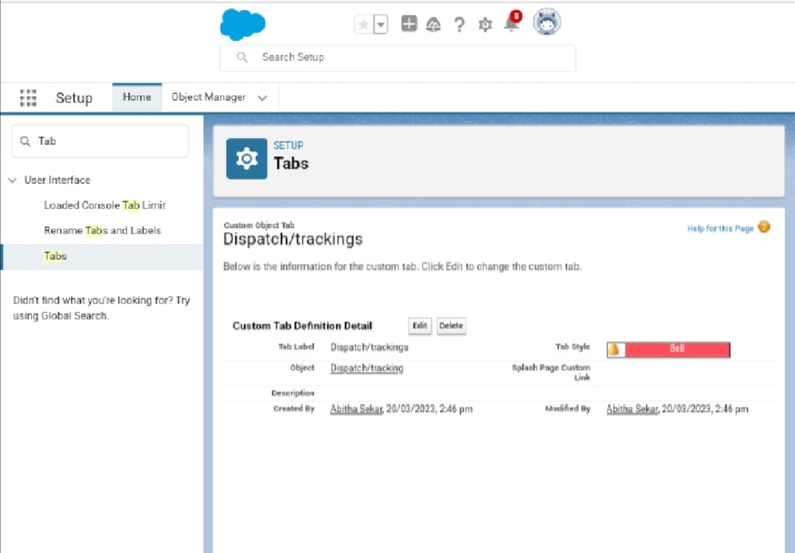

Creation of Tab (Dispatch/tracking , Display/tracking , Dispatched , Sales order , Tracking Id)

Milestone 5:

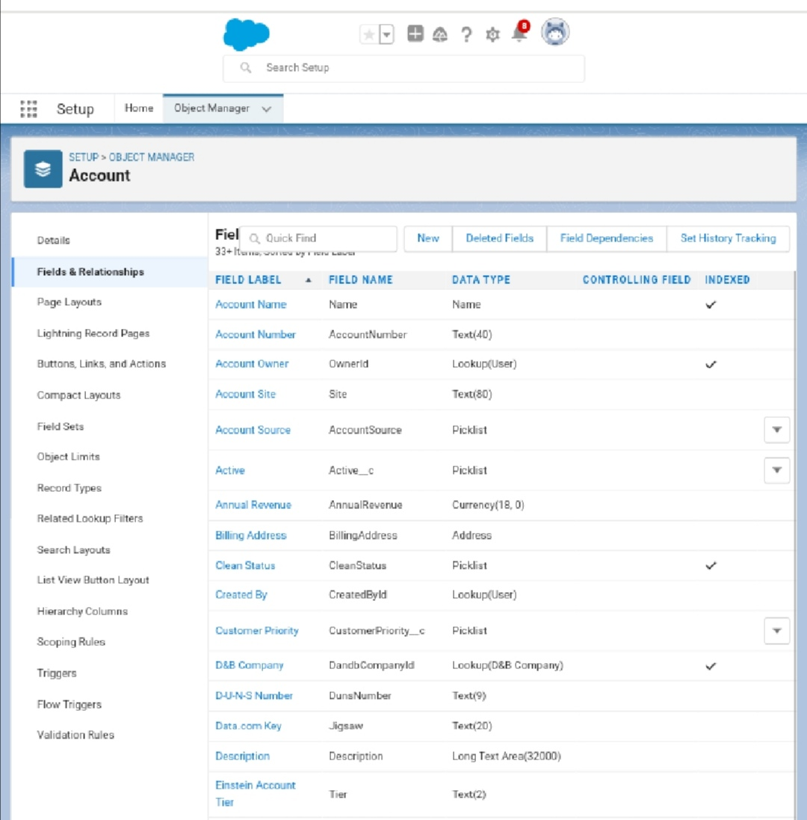

Create of Fields(Display/tracking, Dispatch/tracking, Dispatched, Sales order, Tracking Id)

Milestone 6:

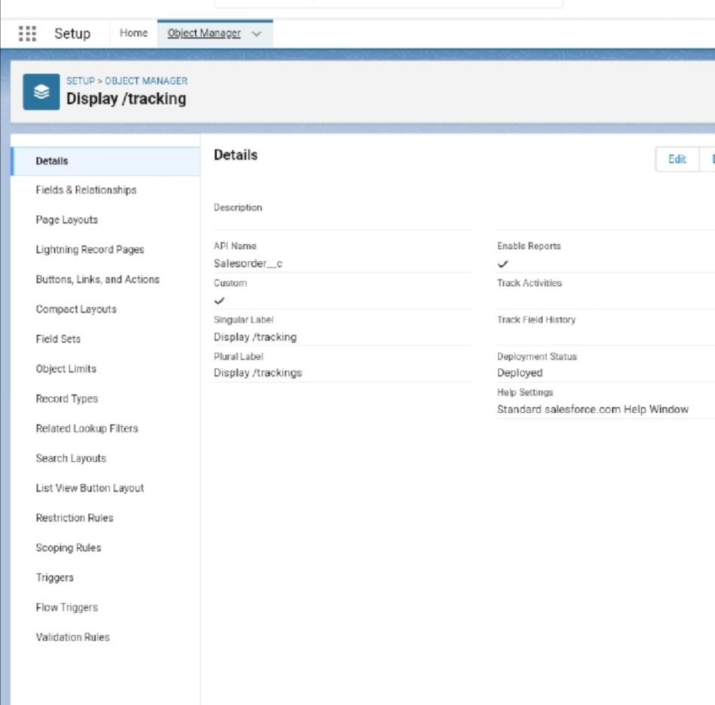

Creation of Junction Object (Display/tracking)

Milestone 7:

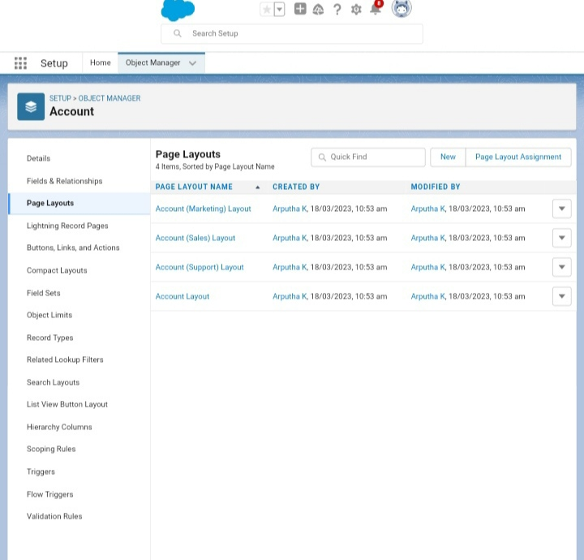

Creation of page layout ( Account & Review)

Milestone 8:

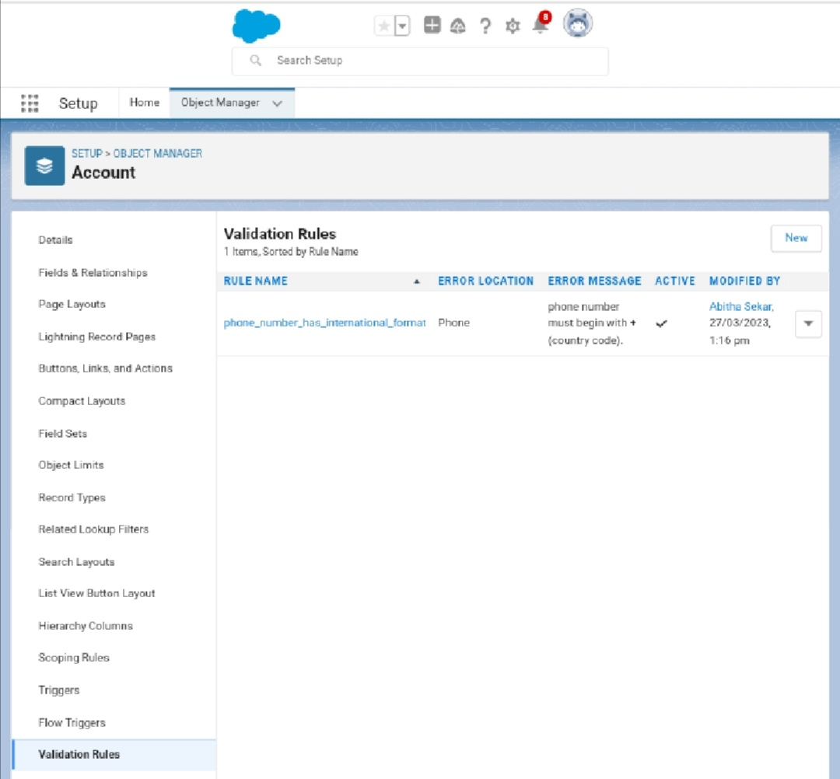

Creation of Validation Rule ( Phone Number has international format)

Milestone 9:

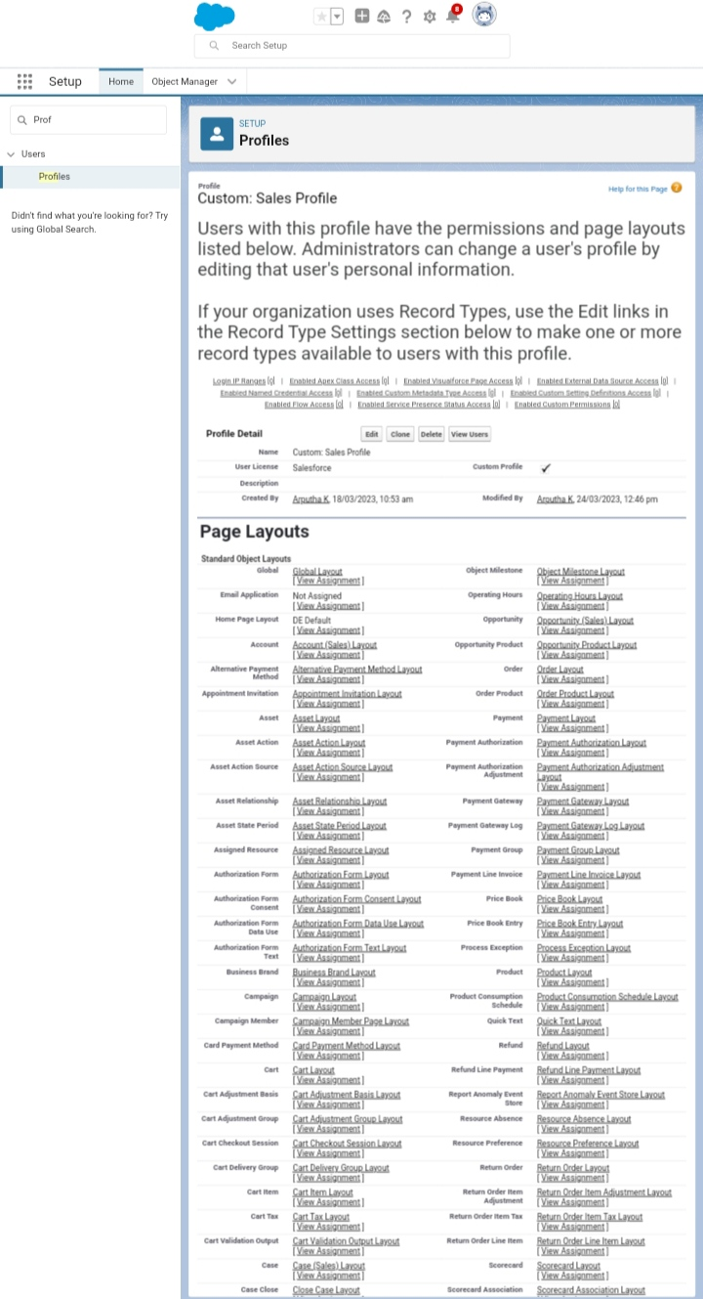

Creation of Profile (Custom User Profie & Sales Profile)

Milestone 10:

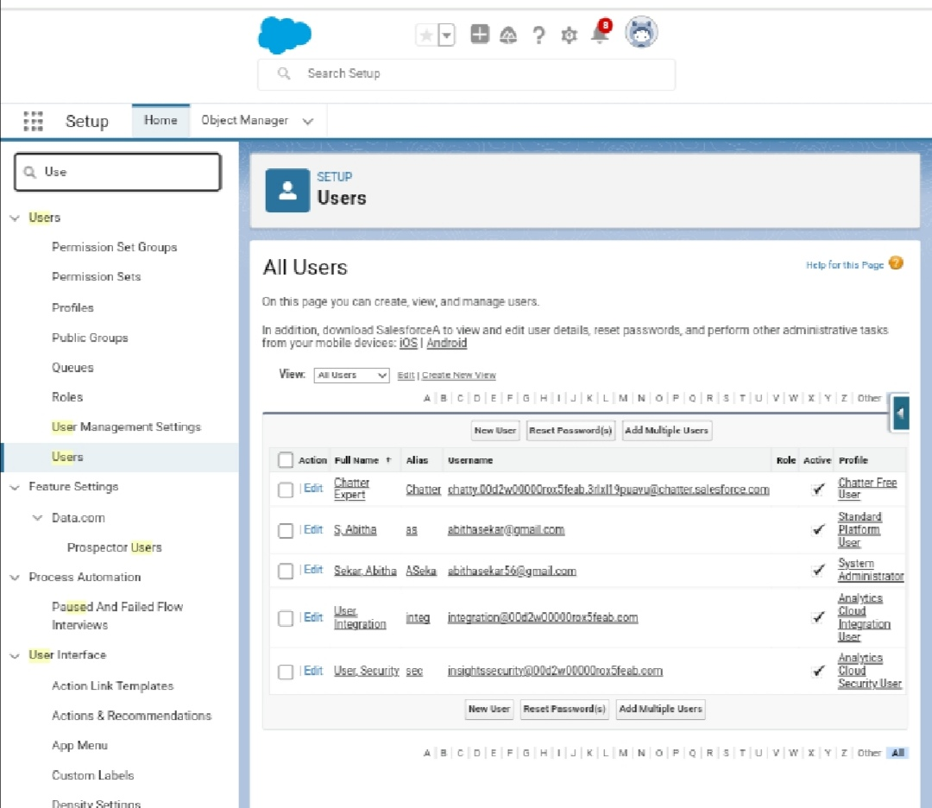

Creation of users

Milestone 11:

Creation of Validation Rule(Phone number has internal format)

Milestone 12:

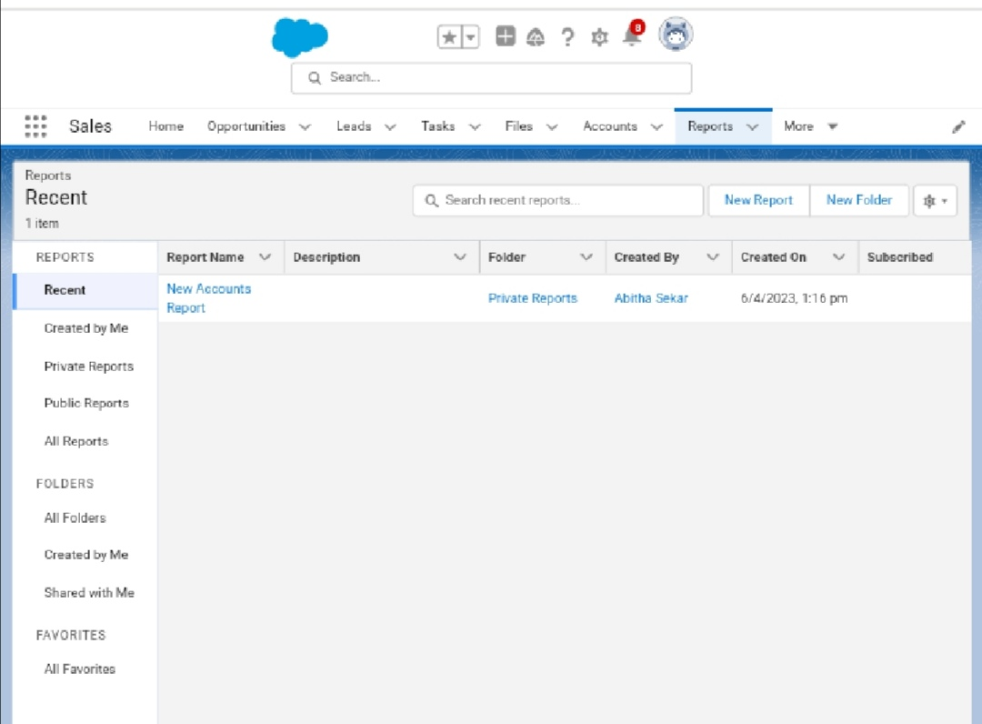

Createion of Reports (New Accounts & Review)

# 4 TRAILHEAD PROFILE PUBLIC URL

Team Lead - https://trailblazer.me/id/arpuk

Team Member 1 - https://trailblazer.me/id/abina239

Team Member 2 - https://trailblazer.me/id/mabirami1

Team Member 3 - https://trailblazer.me/id/asekar48

# 5 ADVANTAGES & DISADVANTAGES

* Less capital Requirement.
* More profit Margin.
* High Marketing Cost.
* High Competition, Good Selling Skill is Required.

# 6 APPLICATIONS

* Department of Large Store manage through promotion department of the store.
* Small Retailers pool resources with manufacturers for promotions.
* Print news papers, magazines, direct mail and AV media like TV, radio.

# 7 CONCULUSION

* The consumer prefer the product from various reason as like 35%consumer prefer the product for its price, 30% for its quality,15% for its packing but 20%consumer have not certain idea or other various reason.

# 8 FUTURE SCOPE

The future landscope of Retail Management it that customer can shop online at their favourite store, Choose products they love, Intract eith customer care staff, and make a purchase without leaving the house.